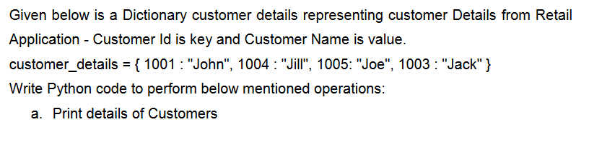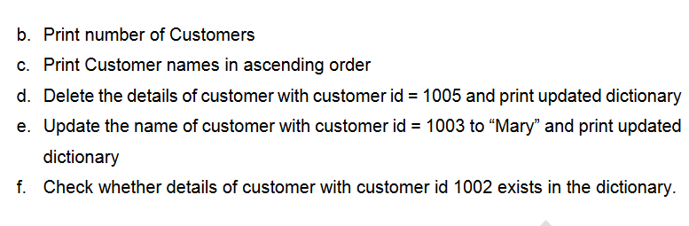

1. **Cate Hospital wants to know the medical specialty visited by the maximum number of patients. Assume that the Patient id of the patient along with the medical specialty visited by the patient is stored in a list. The details of the medical specialties are stored in a dictionary as follows:**

**{**

**“P”:”Pediatrics”,**

**“O”:”Orthopedics”,**

**“E”:”ENT”**

**}**

**Write a function to find the medical specialty visited by the maximum number of patients and return the name of the specialty.**

**Note: Assume that there is always only one medical specialty which is visited by maximum number of patients.**

**Sample Input Expected Output**

**[ 101, P, 102, O, 302, P, 305, P] Pediatrics**

**[ 101, O, 102, O, 302, P, 305, E, 401, O,656, O] Orthopedics**

**[ 101, P, 102, E, 302, P, 305, P, 401, E, 656, O, 987, E] ENT**

1. **ARS gem store sells different variety of gems to customers. The dictionary of gems and its price[gems as key and price as value] are given below:-**

**Gem Emerald Ivory Jasper Ruby Garnet**

**Price in Rs. 1760 2119 1599 3920 3999**

**Write a python program to calculate and display the bill amount to be paid by the customer based on the list of gems(gem_list) and quantity purchased(qty_list). Quantity purchased must be greater than 0. The customers are also entitled for discount based on gems purchased. Refer the table below for discount provide. In case more than one discount is applicable, the total discount % should be applied on the total bill amount.**

**Gems Discount**

**Ivory 3%**

**Ruby 4%**

**Others 6%**

**In case of invalid values for any of quantity purchased or gems required display bill amount=-1.**

**Initialize required gem_list and qty_list containing names of gems to be purchased and required quantity of purchase for a customer and display the bill amount.**

1. **Exercise23Day4(InfyTQ)**